**Department of Artificial Intelligence**

**College of Computer and Cyber Sciences**

***Introduction to EON-XR***

1. **Objectives**

By the end of this lab, students will:

* Activate their **EON-XR account**.
* Download and install the **EON-XR application**.
* Explore and understand **Sketchfab** for 3D content.
* Create an **interactive lesson** using the EON-XR app.
* **Publish** their lesson for others to view.

1. **Lab Requirements**

* **Software:** 
  1. **EON-XR Account:** Students must have an active account on EON-XR.

([EON-XR - Sign In](https://core.eon-xr.com/Identity/Account/Login))

* 1. **Sketchfab Account:** A Sketchfab account is required for accessing and integrating 3D models into lessons.

([Sketchfab - The best 3D viewer on the web](https://sketchfab.com/))

* 1. **EON-XR App:** The EON-XR application should be downloaded and installed on the student device.

1. **Key Concepts**

* **What is EON-XR?**

EON-XR is an advanced platform for creating, developing, and distributing interactive lessons in augmented reality (AR) and virtual reality (VR). It allows educators to design immersive content quickly and effectively, making it easier to engage students and enhance learning experiences.

* **Why Use EON-XR?**

Versatile Accessibility: Works on any Wi-Fi-enabled device, including tablets, smartphones, and desktops, with full AR and VR support.

Quick Lesson Creation: Create interactive lessons in just minutes, ranging from simple visualizations to more complex content.

Flexible Delivery: Share lessons with individuals, groups, or the public. Lessons can be pre-recorded or delivered live.

1. **Preparation and Setup**
   1. **EON-XR Account:** To activate your EON-XR account, follow these steps:
      1. Go to your university email inbox.
      2. Find an email with the subject "Activate Your EON-XR Account."

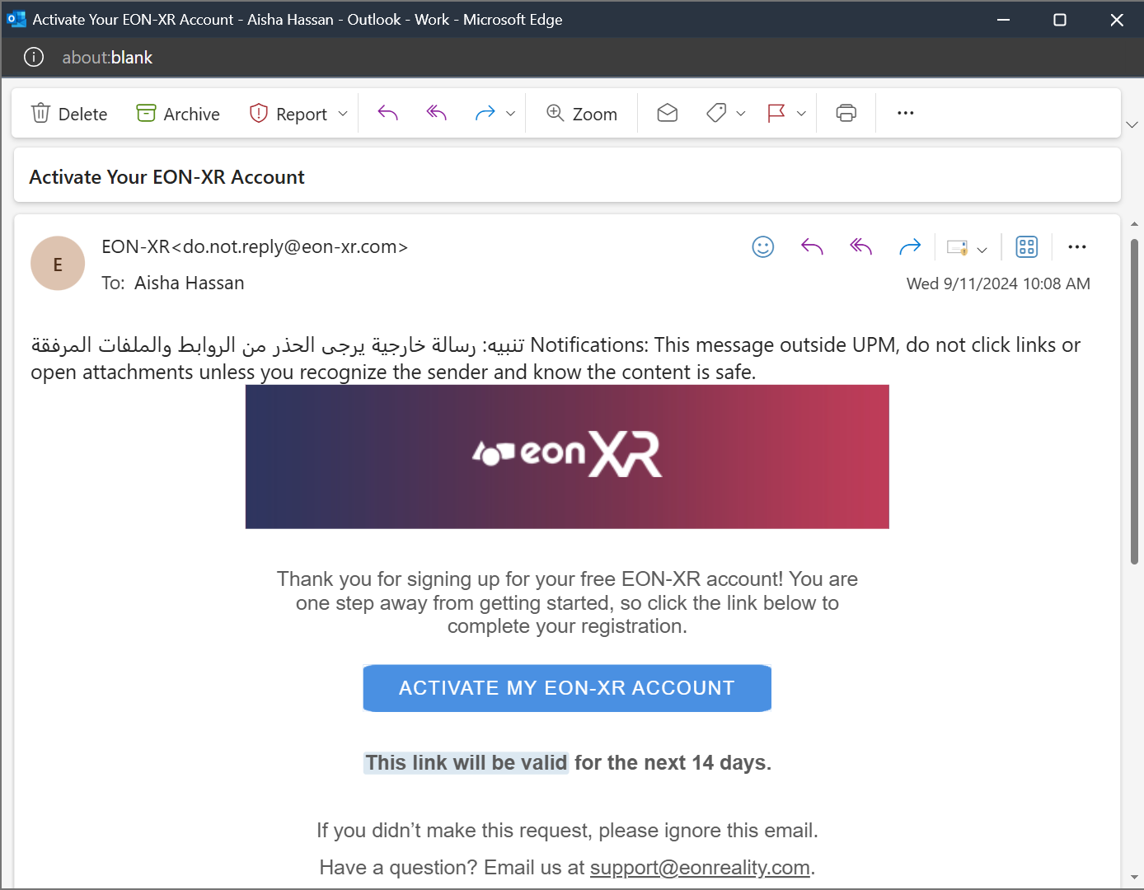

* + 1. Click the "Activate my EON-XR account" button in the email.

* + 1. You will be redirected to the EON-XR website.

* + 1. Use your student email to log in and create a password for your account.

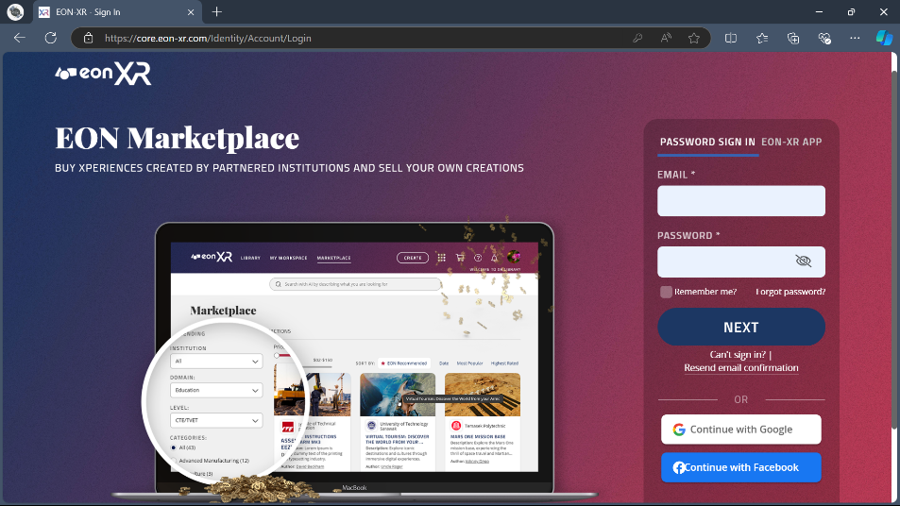

* 1. **Sketchfab Account:** ([Sketchfab - The best 3D viewer on the web](https://sketchfab.com/)). To create a Sketchfab account, follow these steps:
     1. Follow the link provided above to visit the Sketchfab website.
     2. You will be directed to the home page.

* + 1. Click the "Sign up" button.

* + 1. Enter a username, your student email, and set a password.

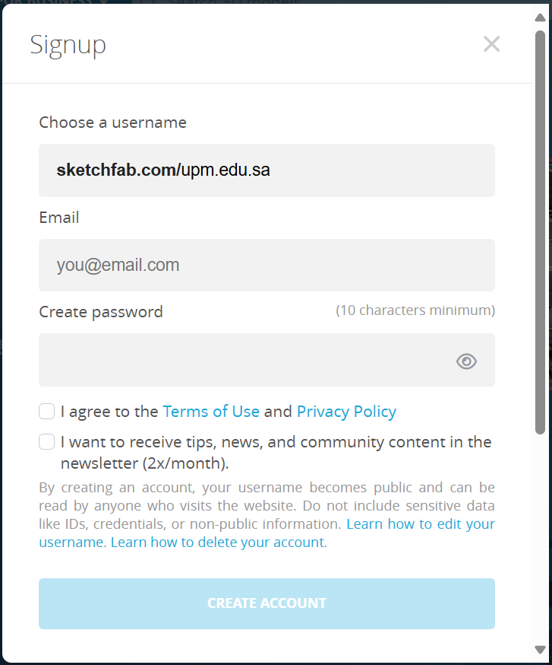

* + 1. Click "Create account" to complete the process.



* 1. **EON-XR App:** To download and install the EON-XR app, follow these steps:
     1. Log in to your newly created EON-XR account.
     2. Click on your **profile** in the top-right corner.



* + 1. Find the **Downloads** section under your profile.

* + 1. Select your **operating system** (e.g., macOS, Windows) and click on it.

* + 1. The download process will start. Wait until it is complete.
    2. Go to your **Downloads folder** and locate the EON-XR installer file.
    3. Run the installer and follow the on-screen instructions to install the app on your device.
    4. Once installed, open the EON-XR app and log in using your university email.

1. **Activities**

In this lab, you will create a simple interactive environment.

* **Exercise 1: Creating an Interactive Environment**

In this exercise, students will create an environment using the EON-XR app with an AI persona and integrate a 3D model.

Step 1: After opening your app, from the four options choose “Create”.

Step 2: Select an **AI persona** to add to your environment.

Step 3: Choose the “Education” Sector from the list, then select one of the available topics under it.

* For this exercise, select "Maths, Science, & Engineering".

Step 4: Within the selected topic, choose from the available branches.

* We will choose "Introduction to Biological Sciences" under “Biological Sciences”.

Step 5: Proceed to the Next Step by clicking the “Next” button.

Step 6: Select an **image** to use as the **thumbnail** for your lesson.

Step 7: After the AI assistant finishes its explanation, click the “Continue” button.

Step 8: A list will appear, prompting you to select **keywords** related to your 3D model. Choose from the list and click “Next”.

Step 9: The **XR library** will open, displaying a list of models related to your selected keywords.

* You can also choose to search for models in the “Sketchfab library”.

Step 10: Select a 3D object from the list that fits your lesson and click “Next”.

Step 11: Place your chosen **3D model** within the environment.

Step 12: You will now see your 3D model alongside the AI assistant in the environment.

Step 13: Once the AI assistant finishes its explanation, press the “Continue” button.

Step 14: A list of additional activities will appear. Choose "End wizard".

* **Exercise 2: Exploring Tools and Adding Content**

In this exercise, students will learn to use the main tools in the EON-XR app and add additional content to their environment.

Step 1: Use the **question symbol** on the top right of the screen to view the usage of each icon on the main page. This will help you understand the function of each tool.

Step 2: Use the **move**, **rotate**, and **scale** tools to adjust your 3D model to the right size and position within the environment.

Step 3: Click on the **Add Content icon**. You will see a variety of options for adding new elements.

Step 4: Add a **second object** to the environment, place it next to the first one, and adjust its scale to fit the scene.

Step 5: Add a **voice annotation** to a part of the 3D model and give it a **name**.

Step 6: Select the annotation you added, then click the **plus icon** to add different types of content:

* Add voice text.
* Add an image.
* Add a video.
* Add a PDF.
* Use the upload option to add a voice recording.
* Add a URL to provide additional resources.

Step 7: Use the **Show Knowledge Portal icon** to preview your work. Verify that all the content you added is functioning as expected.

Step 8: Use the "X" icon at the top left to **save** your work and **exit** the environment.

Step 9: Go to your account and navigate to "My Workspace". You should find your class and the content you created listed there.

* **Exercise 3: Exploring EON-XR on your phone (optional)**

In this exercise, you can use your phone to explore the class you created in the previous exercise.

1. **Submission**

Students should follow these steps to submit their work:

* Use the **"Share"** option located above the lesson in the EON-XR app.

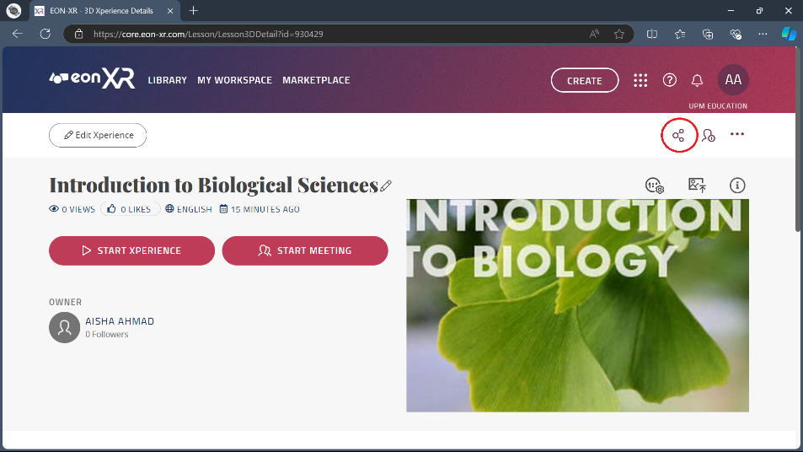

* **Copy the link** provided for your lesson.



* **Paste the link** into a Word document.

1. **References**

[EON XR: Leading Spatial AI & Virtual Reality Education (eonreality.com)](https://eonreality.com/eon-xr/)

[EON XR's New Products & Features: EON Train AI & Metaverse Builder on Desktop (Step by Step Guide) (youtube.com)](https://www.youtube.com/watch?v=vUjDXSumQ7o)

[EON-XR - Create a 3D lesson on desktop with EON-XR (youtube.com)](https://www.youtube.com/watch?v=qNr-S2xdvcE)

[EON-XR Experience Creation in 8 Simple Steps (youtube.com)](https://www.youtube.com/watch?v=fPhGeW_GR-U)

[EON-XR Desktop Platform - EON-XR User Guides documentation](https://docs.eon-xr.com/HTML/Desktop/desktopEON-XR.html)